ALL TEST 6.31 Analysis Results

Performance Summary

Bottom Line
This induction motor is operating normally, no action is required.
X This induction motor exhibits suspicious operation, trending of the induction motor is warranted.
This induction motor exhibits abnormal indications, action is warranted, NOW.

Power Factor Commentary
Power factor exceeds 0.85.
X Power factor is below 0.85, see detailed report.

Current Commentary
X Current variation is within normal limits.
Current variation is beyond normal limits, see detailed report.

Voltage Commentary
X Voltage variation is within normal limits.
Voltage variation is beyond normal limits, see detailed report.
RMS voltage differs from nameplate by more than 5%.

Load Commentary
X Load on the induction motor is consistent with nameplate values.
Load on the induction motor exceeds nameplate values, see detailed report.
Load on the induction motor is less than 25%.

Phase Connection Commentary
X Connections are normal.
Voltage ground reference is NOT neutral.
Loose connection.

Rotor Commentary
Rotor bar health is normal.
X Rotor bar health is questionable, see detailed report.
Load is insufficient to determine rotor bar health, at this time.

Stator Commentary
X Stator health is normal.
Stator mechanical health is questionable. .
Turn to turn short.

Rotor/Stator Air-gap Characteristics
X Dynamic or static eccentricity indications do not exist.
Indications of static eccentricity exist .
Indications of dynamic eccentricity exist.

Harmonic Distortion Commentary
X There is no evidence of harmonic distortion.
There is evidence of harmonic distortion, see detailed report.

Misalignment Indications
X There are no indications of mechanical problems like misalignment or unbalance.
There are indications of mechanical problems like misalignment / unbalance. Perform vibr. survey to identify and correct the cause.

INPUT SUMMARY

NAMEPLATE INFORMATION
 |  | Units
Model Number | Y2-2805-6
Tested Equipment | Induction
Power | 60.32 | HP
RPM | 980.0 | Rpm
Poles | 6
Phases: | 3
Voltage | 380.0 | Volt
Full Load Current | 85.40 | Amp
No Load Current | 3.00 | Amp
Number of rotor bars | 34
Number of stator slots | -1
Torque | 323.1 | Ft.Lb
CT Ratio | 1.000
Service Factor | 115
Motor efficiency | -1.000
Power factor | 0.860

Description:
Belum ada data rotor bar dan stator slot

LEGENDS:
Impedance | = Complex Impedance = vi/ci
CF | = Crest Factor = (waveform peak)/(waveform rms)
VDF | = Transformer Harmonic De-rating Factor = sqrt(2)/CF, %

Slip % | = SRSS sum of slip and harmonic "levels" divided by RMS level of RMS DEMOD spectra between 0 and 65 Hz.
Upper sb | = dB level of upper slip sideband of power line peak
Lower sb | = dB level of lower slip sideband of power line peak
Se, fund | = Location of pole pass frequency fundamental, Hz
Se, harm | = Number of pole pass frequency harmonics
Rotor bar health | = Estimate of the percent of broken or cracked rotor bars
RB Hlt Index | = Rotor bar health index

THDF | = Voltage De-rating Factor = 100 - (voltage unbalance, %)^2, %
Level | = Sum of spectral amplitudes of pole pass frequency fundamentals and harmonics
Thd | = Total harmonic distortion
+Ve | = Positive sequence harmonic
-Ve | = Negative sequence harmonic
Zero | = Zero sequence harmonic

Detailed Calculations

Running Speed = 16.449 Hz [987 RPM]

Pole pass frequency = 1.282 Hz [77 RPM]

Load = 31.0 %
Time
 | RMS | Peak | CF
Current 1 | 39.240 | 59.552 | 1.518
Current 2 | 39.990 | 60.690 | 1.518
Current 3 | 39.140 | 59.400 | 1.518
Average | 39.457 | 59.881 | 1.518
% dev | 1.4 | 1.4 | 0.0

THDF = 93.2

Time
 | RMS | Peak | CF
Voltage 1 | 377.500 | 545.390 | 1.445
Voltage 2 | 377.700 | 545.680 | 1.445
Voltage 3 | 376.900 | 544.530 | 1.445
Average | 377.370 | 545.200 | 1.445
% dev | 0.1 | 0.1 | 0.0

VDF = 100.0
* Note-
Phase 2 and 3 CF and peak entries are assumed to be the same as phase-1.

 |  |  | App. Power | Real Power | Reac. Power
 | Power factor | Impedance | kVA | kW | kVARS
Phase 1 | 0.601 | 9.620 | 8.546 | 5.135 | 6.832
Phase 2 | 0.592 | 9.445 | 8.722 | 5.165 | 7.028
Phase 3 | 0.579 | 9.630 | 8.513 | 4.927 | 6.942
Avg/Total | 0.591 | 9.565 | 25.781 | 15.227 | 20.802
% dev | 2.0 | 1.3

Demand Pwr = 20.41 HP

Load:31.0 %

Motor Eff.:89.6 %

Loss due to THD:

Output Pow.:13.34 KW

Output Trq.:95.09 Ft.Lb

Summary of Rotor Bar Health |  |  |  |  | Power line dB diff. |  | RB Hlt Index
 | Se, fund |  | Se, harm | Level % | Upper SB | Lower SB | RB Hlt Index
Measured | 1.282 |  | 4 | 0.9 | -40.897 | -39.448 | 1.665
Severity level |  | Rotor Condition Assessment |  |  | Recommended Corrective Action
6 |  | Multiple cracked or broken rotor bars and end rings indicated. Also joint and ring problems |  |  | Overhaul ASAP

Harmonic Distortion Results:
Voltage input, from 50.049 Hz harmonics
 | THD Odd % | THD Even % | +ve% | -ve % | Zero % | THD All %
Current 1 | 5.213 | 0.541 | 2.755 | 4.435 | 0.450 | 5.241
Current 2 | *** | *** | *** | *** | *** | ***
Current 3 | *** | *** | *** | *** | *** | ***
Voltage 1 | 2.130 | 0.050 | 1.278 | 1.695 | 0.175 | 2.130
Voltage 2 | *** | *** | *** | *** | *** | ***
Voltage 3 | *** | *** | *** | *** | *** | ***

Harmonic distortion table – Peak values, voltage is phase to ground
Hz | Cur1 | Vlt1 | Cur2 | Vlt2 | Cur3 | Vlt3
50 | 55.0 | 303 | *** | *** | *** | ***
100 | 0.3 | 0 | *** | *** | *** | ***
150 | 0.3 | 0 | *** | *** | *** | ***
200 | 0.1 | 0 | *** | *** | *** | ***
250 | 2.5 | 5 | *** | *** | *** | ***
300 | 0.0 | 0 | *** | *** | *** | ***
350 | 1.5 | 4 | *** | *** | *** | ***
400 | 0.0 | 0 | *** | *** | *** | ***
450 | 0.0 | 0 | *** | *** | *** | ***
500 | 0.0 | 0 | *** | *** | *** | ***
550 | 0.5 | 2 | *** | *** | *** | ***
600 | 0.0 | 0 | *** | *** | *** | ***


Figure 1: Current harmonic distortion plot

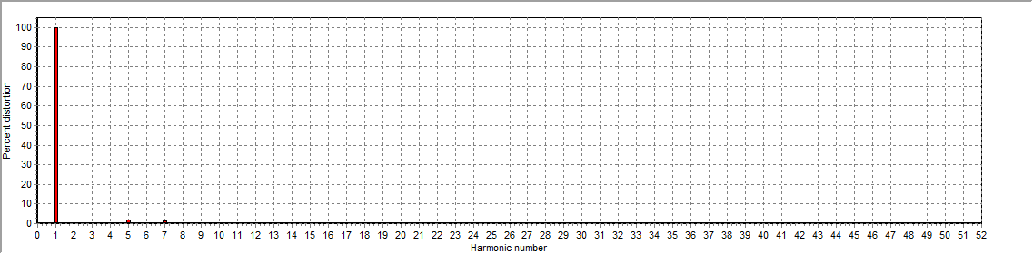
Figure 2: Voltage harmonic distortion plot

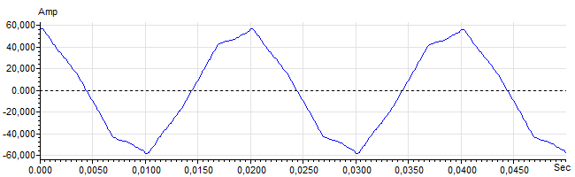
Figure 3: Raw Current

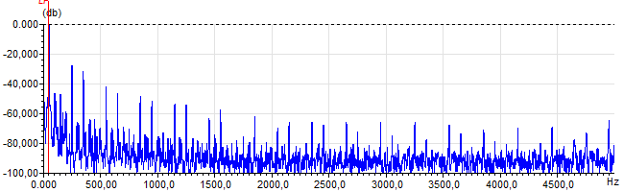
Figure 4: Raw Current Frequency spectrum

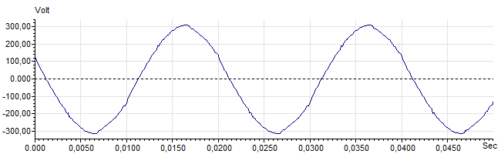
Figure 5: Raw Voltage

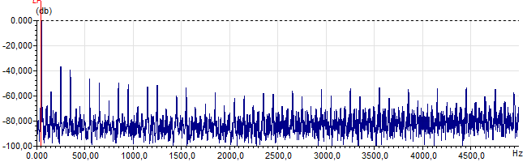
Figure 6: Raw Voltage Frequency spectrum

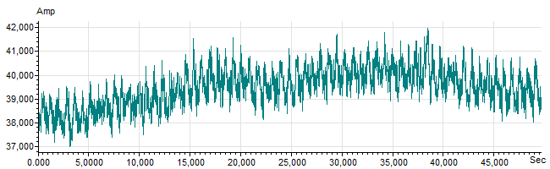
Figure 7: Demodulated current trace

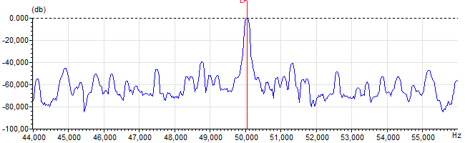
Figure 8: Raw current spectrum

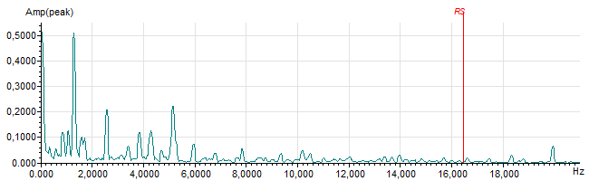
Figure 9: Demodulated current spectrum

